Pages

Pages are used to display all types of web content: Text/tables/documents/images

Pages may be public or private

NB: ‘Home’ page cannot be edited using this method. See Dashboard – Theme settings – Home page layout

Adding a new page.

  - Firstly decide on your page name/title and where the page should reside, ensuring consistency with site hierarchy
- In the dashboard, from the pages menu, select add new OR select the ‘+New’ group on the top menu of the dashboard and select page
- Add title and content
- On the RHS, in Page Attributes, select the ‘Parent’ page from the dropdown.
- Submit for Approval – in the resulting dialogue box – type in a comment to help the approver to sign off the page. (NB – users with approver status will have choice to either submit for approval or to instantly publish)

Editing text content on an already published page

  - When a page which has already been approved and published requires editing, a review copy of that page will be made. This allows the updated page to be submitted to the workflow for approval whilst the original page remains live on the site. Once the updated page is approved, this will over-right the original page on the live site.
- Open the page in edit view
- Click on the ‘make revision’ button on the RHS – notice the page title change to ‘Review copy of – page name’
- Make your edit
- Click the ‘submit for approval’ button on the RHS’
- Enter comment to explain edit made.
An email notification will now be sent to all approvers to advise that the page is awaiting approval.

Making a page visibility ‘Private’

Making a page private renders the page ‘ invisible’ to all website visitors but the page will still be accessible by all content editors. This is a useful way of temporarily suspending a page and can easily be made public again.
NB: This change can only be made by an approver
- Open the page in edit view
- If it is necessary to submit this through workflow – then select ‘Make revision’ option (if now workflow required, go to step 3
- In the Publish box on RHS, click edit on visibility, then choose the private option
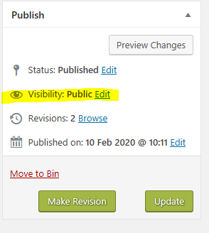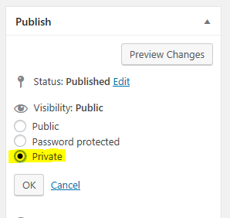
- Depending on route chosen at step 2, either submit for approval or update.

- To find a private page (make it public again)
NB: This change can only be made by an approver
- In Dashboard – Pages : click on Private at top of page
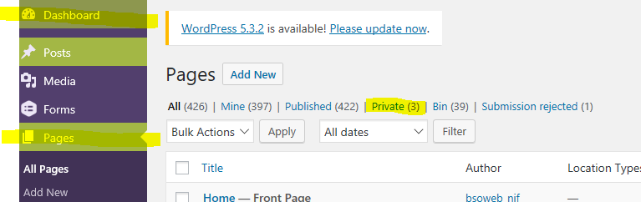
- From the list of private pages, chose the edit option for the page and carry out steps at Point 3 selecting the ‘Public’ option

Deleting a page

  - Be sure that the page is to be deleted and any replacement page is published
NB: This change can only be made by an approver
- Within the Website content – navigate to required page
- Click Edit Page on top menu
- In the RHS below the Publish box, select ‘Move to Bin’
OR
- In the ‘Pages’ group in the dashboard, select all pages and use the search facility to find the page which is to be deleted
- Hover the mouse pointer over the page title to display available options and select ‘Bin’

NB: The page can still be restored until deleted permanently
In Pages, select ‘Bin’ category, hover mouse pointer over page title and select ‘Delete Permanently’

Headings and Styles

Main Headings (i.e Prescribing Notes) | Heading 3
Sub Headings | Heading 5
New Line | Shift + enter
Line Space | Alt + Enter

NB: When editing content it may look quite different than preview mode. Always preview to check formatting

Anchors (also referred to as bookmarks or jump marks)

You can create a bookmark from one point in a page to another point in the same page or in a different page

The Anchor point is the location where you want the user to access quickly and the Link Text is the text that the user will click to get to that anchor point.

Anchor and link on same page
- In page edit mode, Place the cursor where you require the anchor to be placed and click the ‘Anchor‘ Icon
NB: Data below the Anchor point only will be displayed when Link text is clicked so usually better to place the anchor at start of topic heading
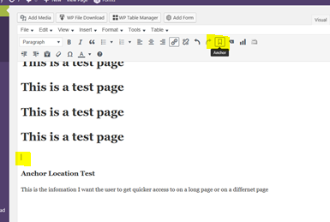

- Give your anchor a short name and ‘OK’
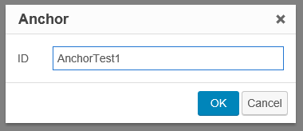

You should now see a small Anchor symbol where you placed the anchor 
- Highlight the link text and click the Insert/Edit link icon 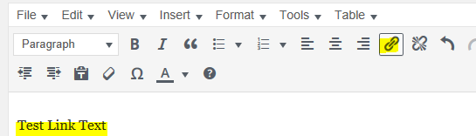

- Type # followed by Anchor Name and apply 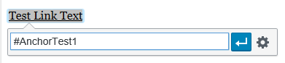

- Preview and check that the link works. Close preview and submit for approval

Anchor and link on different page

- Follow steps a) to b) above
- Go to the page where the link text is required and follow step c)
- In the link dialogue box, click on the settings cogwheel and in the #Or link to existing content’ search box, search for page containing the anchor (1)
- Click on the page name (2) and the URL box at the top will be populated – at the end of the URL type Type # followed by Anchor Name (3) – Add Link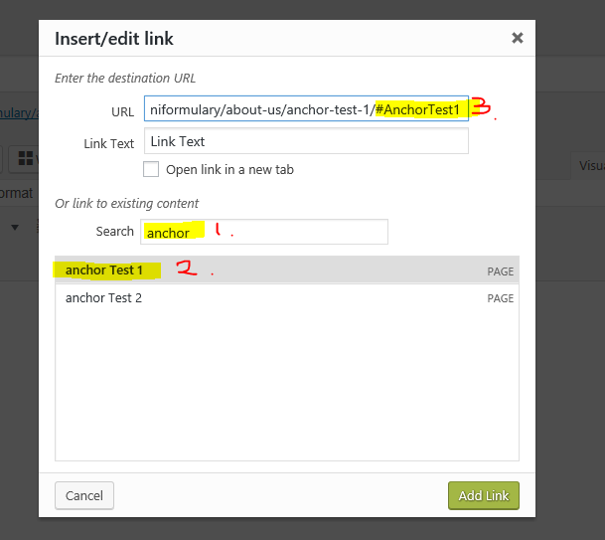

- Preview page and test link

- Submit to workflow for approval.

