Pictures
  - Pictures should be saved to a relevant folder in the media library. Check the library for pictures before adding a new picture.

To add a new picture to the media library from your computer directory

- From dashboard, open the Media and browse to appropriate folder within the library
- Click the ‘Add New’ button at the top of the page and in the resulting dialogue box, click select files
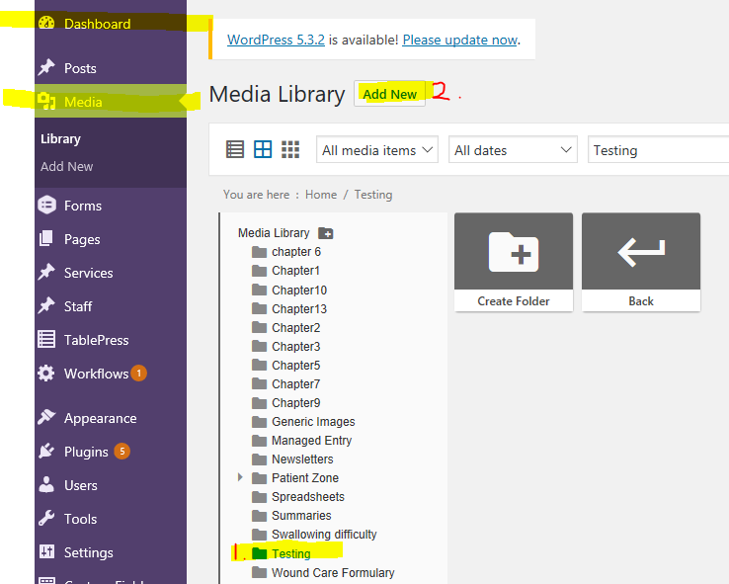
- Browse to the file location of the picture and click open.
- The image should now be available in the media library

To add the picture to a webpage

- Open the page where the picture is to be placed in edit mode
- Select ‘Make Revision’
- In the editing tools panel, select Add Media
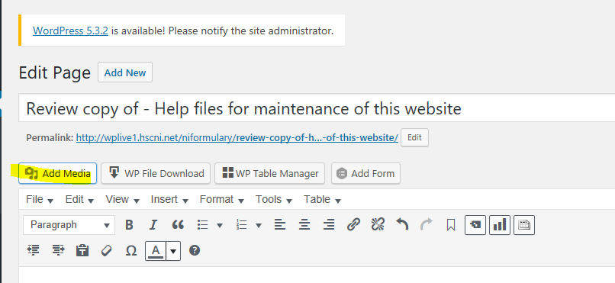
- Ensure Media Library Tab is active then Browse the medial library to find your picture
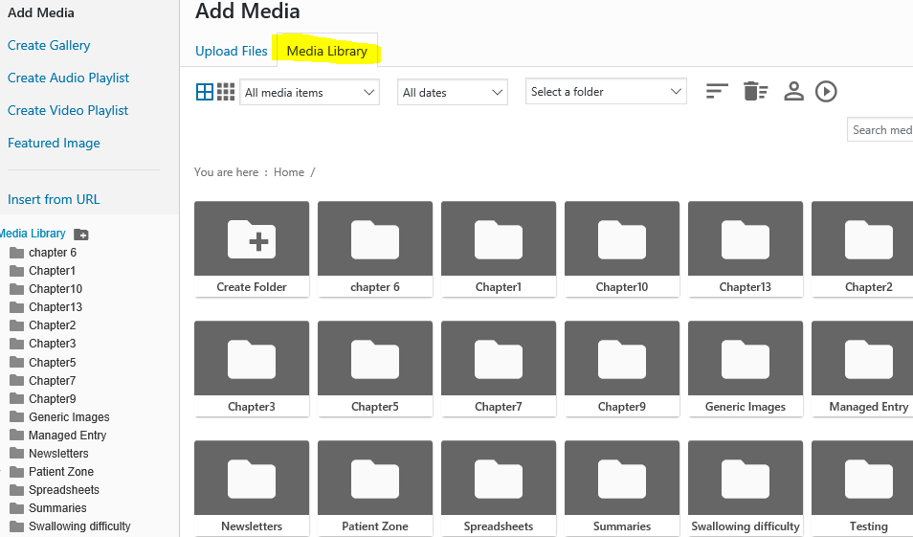
- Select your picture - on RHS, click button ‘Insert into page’
Click on the pencil to edit size and position of the picture and to add a caption if required

