Managed Entry

The Managed Entry table may be edited by any user who has Data Tables Editor permissions.

To add new entry
- In website, open page Managed Entry Decisions
- Click on the 1st record in the table and in the pop-up select +New Entry
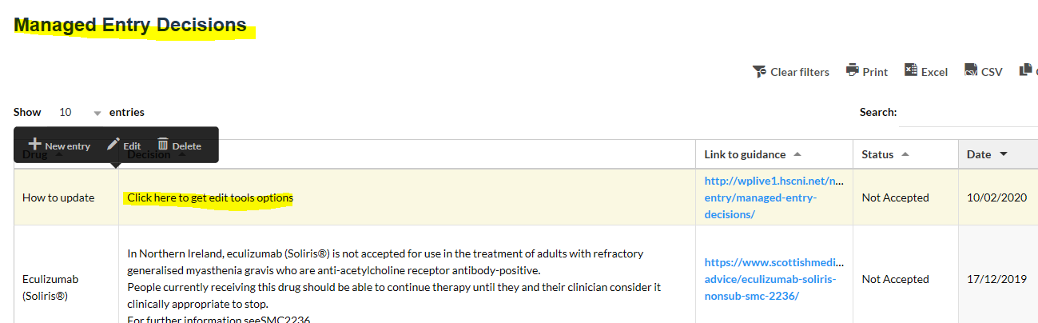
- Complete the Add new entry details and click ‘OK’ if this is the last entry or ‘Apply and add new’ if further entries are to be added.
Note: If Bullets are used in the decision text, it will be necessary to copy and paste from a document in Word where the text is pre-formatted to include the bullets. Additional line spaces however can be added in this editing box.



