WP File downloads for document Management

  - Where a list of documents is required on a page, the documents are filed in WP File Download and then a ‘shortcode’ for the list is placed on the relevant webpage.
  - NB: It is also possible to exclude specific documents from displaying in the list or to create a ‘File direct link’ for an individual document from a list - this can then be used to create a link to this single document from another page
  - Like the Media Library, document categories are created to match the structure of the website.

Create a new document category

- From dashboard, open WP File Download
- Click in the category /level where you want to add a new category and then click the +NEW button at the top of the category listing
- A new category will appear – click the Pencil icon to edit and enter required category description.
- To move the new category up or down in its group, click with the crosshair on the folder icon for it and drag it to desired location in the tree
- Settings can be changed to your preferred settings for display on the webpage. Ensure that these are consistent with other categories in the same group and at the same level
Settings for Newsletters can be found at the end of this guide

Add a document to and existing category

- Click on the category description to open the category
- Click the ‘Select Files’ option and browse to required document(s). NB multiple documents can be selected and added at once
- Click on individual documents to see the settings panel for that document. Here you can amend the title and add descriptions. If the list is sorted by date (category settings) it may be necessary to edit the date that the document was added (document settings)
- If changes are made to the settings, click the orange ‘SAVE SETTINGS’ button

Add a document list to a webpage

- From dashboard, open WP File Download
- Click on the required category description on the LHS
- In the settings panel for the category on the RHS, scroll to the bottom and click on the ‘Category shortcode’ a message will display to say that the code has been copied
- Open the webpage where the list is to be displayed in edit mode.
- Click the make revision button on the RHS and check that a review copy of the page is now open
- Paste the shortcode onto the page; View the page. 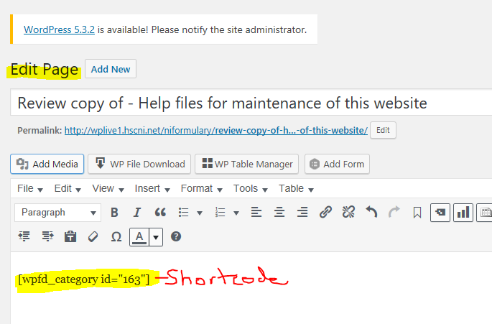
- To change appearance/layout of the documents list - return to the category in WP File Downloads and edit the category settings remembering to SAVE SETTINGS

(See Newsletter Settings at end of this guidance)

Exclude a document from appearing in a list without deleting the document

- From dashboard, open WP File Download
- Click on the required category description on the LHS
- Click on the document that you wish to have excluded
- On the RHS settings panel, at the top, toggle the Published button to OFF and SAVE SETTINGS
- Go to the webpage and check that the document is no longer listed
- This can be reversed by turning the ‘Published’ setting on again

Add a single document link to another web content page

- From dashboard, open WP File Download
- Find document that you wish to use on its own – this can be from a list
- Click on the document and in the settings panel for that document on the RHS, scroll down to File direct Link – copy the link
- Go to required page , use insert link function and paste this link.

Typical Category settings for Newsletters. Other categories may vary.



