Workflow

How to check and approve a workflow item. (approvers only)

The Wordpress workflow works by creating a review copy of the existing published page for editing and approval purposes. When the review copy is approved, it will overwrite the existing published page .
All approvers will receive email notifications when a page is submitted to the workflow. Please do not use the link in the email, but proceed to the workflows in the dashboard and follow guidance as set out below.
- From Dashboard – select ‘workflows - inbox ‘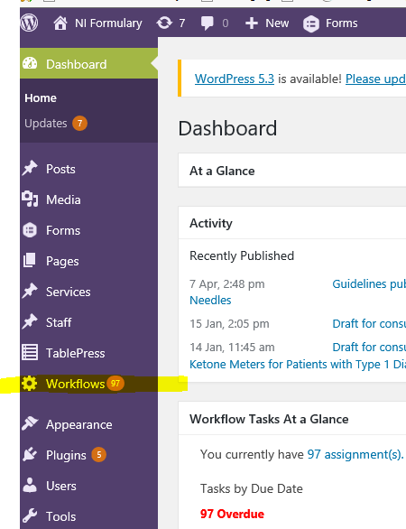
- From the list – select the page that you wish to approve. Note that the most recently added pages will be at the end of the list - the list can be resorted by due date to bring most recently added to the top.
- Click on the ‘comment’ bubble to see what revisions have been made then ‘Claim’ the page 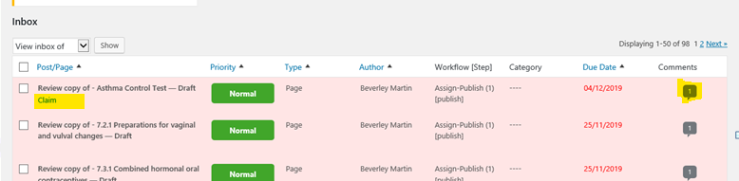
- You will then see further options appearing under the page description –
  - Edit
  - View
  - Sign off
  - Reassign
  - Abort Workflow
  - View History
- Select ‘edit’ to view the page in edit mode and check the revisions are correct. When the contents are checked and verified, click the green ‘Sign Off’ button 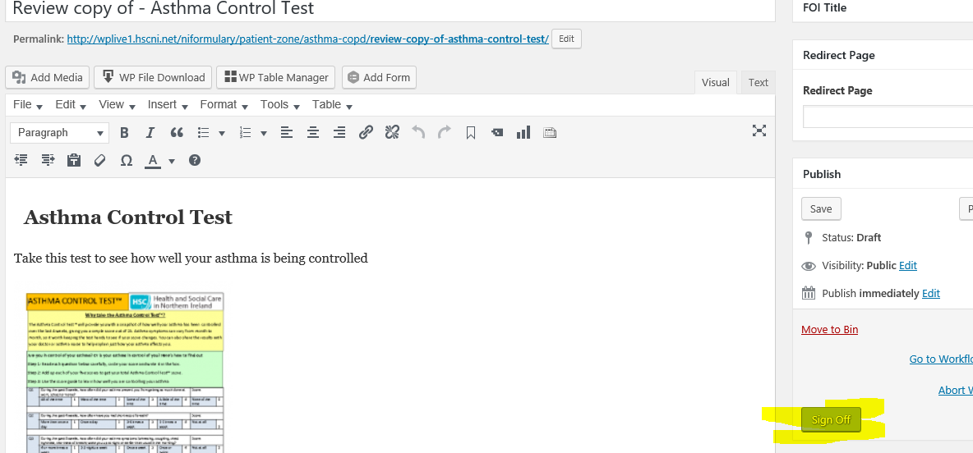
- If further amendments are required, the approver can make further edits and reassign to another approver to verify amendments
- When amendments are received into workflow from an editor, if necessary,the approver may reject the submission and reassign back to the editor for further amendments.
- Select appropriate action form dropdown and ‘Sign Off’ 

