Appendix H
Request for a Medicine to be Added to the Northern Ireland Formulary Chapter/ Prescribing Guidance  Pharmaceutical Industry Form | 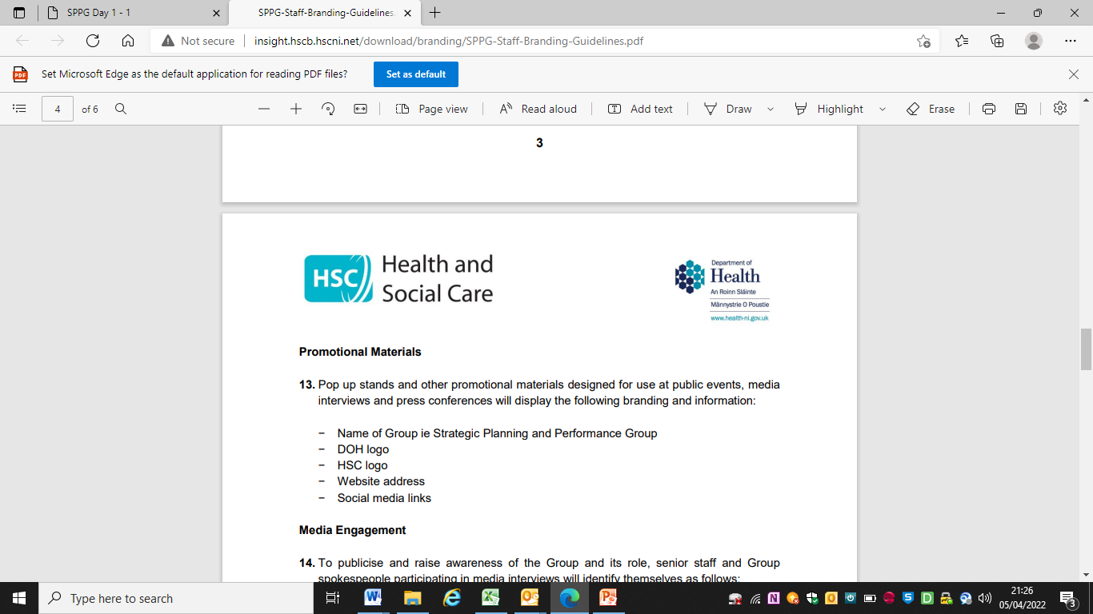

INTRODUCTION
The Northern Ireland SPPG & PHA Process for Developing Prescribing Guidance states that practitioners, HSC Trusts or the Pharmaceutical Industry can ask for consideration of any new medicines for inclusion in the Northern Ireland Formulary/ Prescribing Guidance or the addition of a new indication for an existing medicine. Applications for new drug submissions will normally be considered at least six months after publication of a formulary chapter/prescribing guidance.
The following documentation should be completed in full and submitted with the relevant clinical evidence.
SECTION 1: MEDICINE DETAILS
Generic / Approved name:

Brand name:

Strength/Formulation/Route of Administration:

Manufacturer:

SECTION 2: PLACE IN THERAPY
Licensed Indication(s) [included in the Summary of Products Characteristics (SPC)]:

Indication(s) for proposed use:

Current formulary choices for proposed indication:

Perceived advantages over current therapy:

Are there any perceived disadvantages over current therapy:

Place in therapy (tick all boxes which apply):
First line choice
Second line choice
Replace a current formulary choice (state which medicine is to be replaced)

For restricted use in specific patient groups (provide details)

Tick one box which applies:
Suitable for prescribing / initiation in primary care
Initiation restricted to or on the advice of a specialist
To be used in accordance with protocol (attach a copy of the protocol with the submission)

SECTION 3: NATIONAL GUIDANCE
Has the medicine / formulation / indication been evaluated by the following bodies:
National Institute of Health and Care Excellence (NICE)
Scottish Medicines Consortium (SMC)
Scottish Intercollegiate Guidelines Network (SIGN)
All Wales Medicines Strategy Group

Give details of place in therapy recommended by the bodies above:

SECTION 4: CLINICAL EVIDENCE
Provide details below of key trials that support the submission (attach copies of up to 3 (maximum) relevant references or information in support of the submission)

SECTION 5: COMPARATIVE SAFETY
Provide details of any safety issues regarding this medicine compared to current formulary choices

SECTION 6: TOLERABILITY & ACCEPTABILITY
Provide details below of key information on patient experience regarding this medicine compared to current formulary choices

SECTION 7: SERVICE IMPLICATIONS
Cost of treatment (annual cost or cost of course of treatment if less than 1 year) (state both hospital and primary care costs if the costs are different in the two settings)

Likely duration of treatment

Overall annual /course costs in one year

Additional service implications e.g. specialist assessment, monitoring requirements (state if to be undertaken in secondary care or primary care), aseptic unit preparation, nursing time

SECTION 8: ADDITIONAL INFORMATION
Provide any additional information which may assist in the decision making process

SECTION 9: DETAILS OF SUBMITTING PHARMACEUTICAL COMPANY
Name:

Position within Company:

Pharmaceutical Company:

Member of ABPI:

Send the completed form and any supporting evidence to:
medicines.management@hscni.net

FOR USE OF SPPG ONLY
Final decision | Date | Rationale behind decision

NAME AND SIGNATURE OF CHAIR OF PRESCRIBING GUIDANCE EDITORIAL GROUP
Date

