Name of Nursing Home: | Tel No:
Resident Name: | DOB:
Date: | HCN:

Nursing Assessment Tool for suspected Urinary Tract Infection (UTI) in Older People and Residents with a Catheter: NB this tool is not appropriate for those with recurrent UTI’s or younger residents.

Rationale for resident review:

Consider Could this be Symptoms of Non Urinary Infection?
A. If fever and delirium/debility,  consider possible causes and action taken:  P: Pain ______________________________  I: other Infections _______________________  N: poor Nutrition ________________________  C: Constipation _________________________  H: poor Hydration ________________________  M: other Medications ______________________  E: Environment change ____________________ | B. Consider other possible infection and note action taken:  Respiratory tract infection _____________________  Gastrointestinal tract infection __________________  Skin and soft tissue infection ___________________  Other symptoms ____________________________  ___________________________________________  ___________________________________________

SKIP THE DIP
If UTI is suspected DO NOT perform dipstick
IF SEPSIS IS SUSPECTED SEEK MEDICAL ADVICE IMMEDIATELY

Has the resident one or more symptoms as below |  | If no catheter does the resident have two or more of the symptoms below
With Catheter |  | No Catheter
- Shaking/chills (rigors)  - New central low back (costovertebral) tenderness  - New or worsening of pre-existing confusion, agitation or debility  - New/different myalgia flu-like illness  - Nausea/ vomiting  Remove catheter Yes/No  or  Replace catheter Yes/No  NB- If catheter replaced - send catheter urine specimen from new catheter |  | Tick symptoms which are evident  - Pain on urination (dysuria)  - Urgent need to urinate  - Frequent need to urinate  - New or worsening urinary incontinence  - Shaking chills (rigors)  - Pain side of body or above pubic bone (suprapubic)  - Visible blood in urine (frank haematuria)  - New onset or worsening of pre-existing confusion, agitation or debility  - Nausea and vomiting (can be indication of worsening pyelonephritis)  10. New/ different myalgia, flu like illness
If none of above | UTI unlikely continue to monitor symptoms for 72 hours.  DO NOT USE A URINARY DIPSTICK – DO NOT SEND A SAMPLE FOR CULTURE
If Yes to above | Complete GP referral form overleaf  Collect a urine sample for culture  Management plan: ________________________________________________
Completed by: __________________________________

Relatives informed of outcome if appropriate ________________________________________________________

GP Referral Form for Nursing Home Resident with Suspected UTI
GP Referral Form for Suspected UTI

Clinical Observations

Temperature > 37.9 °C or < 36 °C
On
2 Occasions in 12 hour Period
1 | 2
Date: _____________  Time: _____________  Temperature: _______  BP: _______________  Pulse: _____________  Respirations: __________  0² SATS: ______________ | Date: _____________  Time: _____________  Temperature: _______  BP: ________________  Pulse: _____________  Respirations: __________  0² SATS: ______________

PRESENTING SYMPTOMS AND COMMENTS | Y/N | Date/Time
Increased confusion/delirium
Kidney pain/tenderness in back, under ribs
New/different myalgia, flu like illness
Nausea/Vomiting
New onset of pain passing urine
Visible haematuria
New frequency or urgency
New incontinence
New or worsening delirium/debility
New suprapubic pain

If the patient has had an antibiotic within the last 3 months please document below -
Name and Date of last antibiotic received: ____________________________________
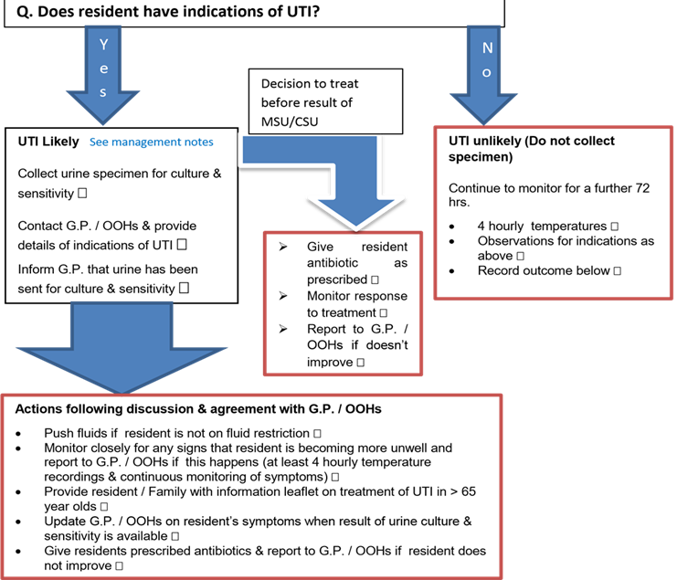
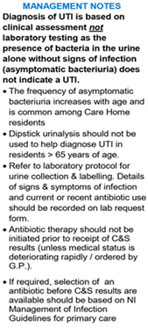

-

If clinical symptoms indicate that antibiotic treatment is required before culture and sensitivity results are available, request will be reviewed by triage doctor and antibiotic issued if appropriate. If antibiotic not required, this will be documented in notes and no meds issued.

- Referral form to be emailed to GP Practice by 12 noon – script will be phoned through to Pharmacy by 4.30pm (Mon-Fri)
- Referral received after 12 noon – script will be ready for collection 9am following day (Mon-Thurs)

Completed by: __________________________________ Email to GP surgery: Time:
Date:


For GP Practice Use:

- No Action Required

- Continue to Monitor for a further 72 hours

- Prescription issued

- Home Visit required

Date:

Scan to access UTI
Decision Aid Tools

